Banking Risk Analytics Dashboard – Project Report

1. Problem Statement
Banks face significant financial and regulatory risk when lending to customers who may default. Poor risk assessment can lead to high non-performing assets (NPAs), liquidity stress, and capital erosion. This project focuses on banking risk analytics using customer, loan, and deposit data to help decision-makers assess repayment likelihood, exposure concentration, and portfolio imbalance before approving or expanding lending.
The objective is to enable stakeholders to: - Identify high-risk clients and segments - Monitor loan-to-deposit imbalance - Detect exposure concentration risks - Support data-driven credit and portfolio decisions

2. Data Overview
The analysis uses historical banking data containing: - Client demographics (gender, nationality, income band) - Banking relationships (Retail, Private Bank, Commercial, Institutional) - Loan details (loan amount, business lending, credit card balances) - Deposit details (savings, checking, foreign currency, total deposits) - Risk indicators (Risk Score: High / Medium / Low) - Engagement tenure (years with bank)
Data was explored and cleaned using Python (Pandas, NumPy, Matplotlib/Seaborn) before visualization in Power BI.

3. Exploratory Data Analysis (Python)
Key EDA steps performed: - Missing value handling and data type corrections - Creation of derived metrics (Loan-to-Deposit Ratio, Client Count) - Distribution analysis of loan amounts and deposits - Risk category distribution across income bands and tenure - Identification of outliers and skewness in loan exposure
Key EDA Findings:
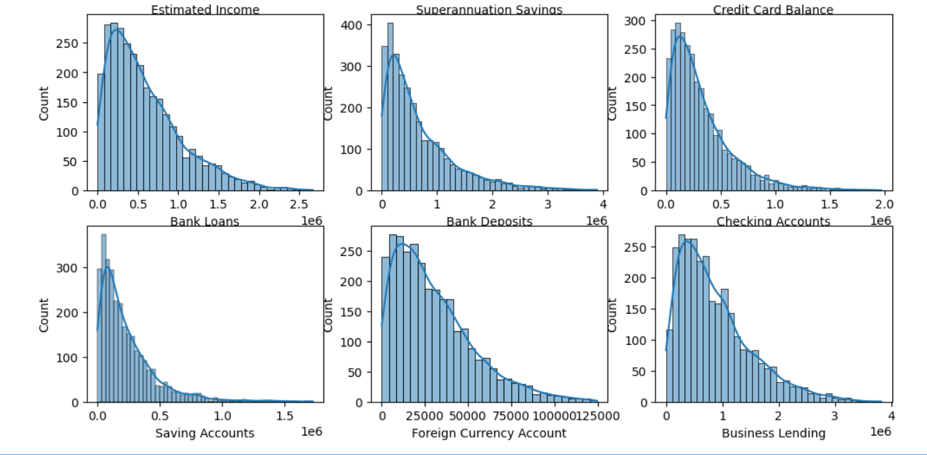
- Loan and deposit values are right-skewed, indicating concentration among fewer high-value clients
- High-risk clients show higher loan exposure relative to deposits - Longer engagement does not always imply lower risk

4. Dashboard Structure (Power BI)
The dashboard is divided into four logical pages, each answering a specific business question.

4.1 Executive Summary
Purpose: High-level portfolio health snapshot
Key KPIs: - Total Clients: 3000 - High Risk %: 32.8% - Total Loan Portfolio: ₹4.38bn - Loan-to-Deposit Ratio (LDR): 116%
Visuals: - Risk distribution donut - High-risk clients by income band - Loan vs Deposit trend - Loans by banking relationship & risk
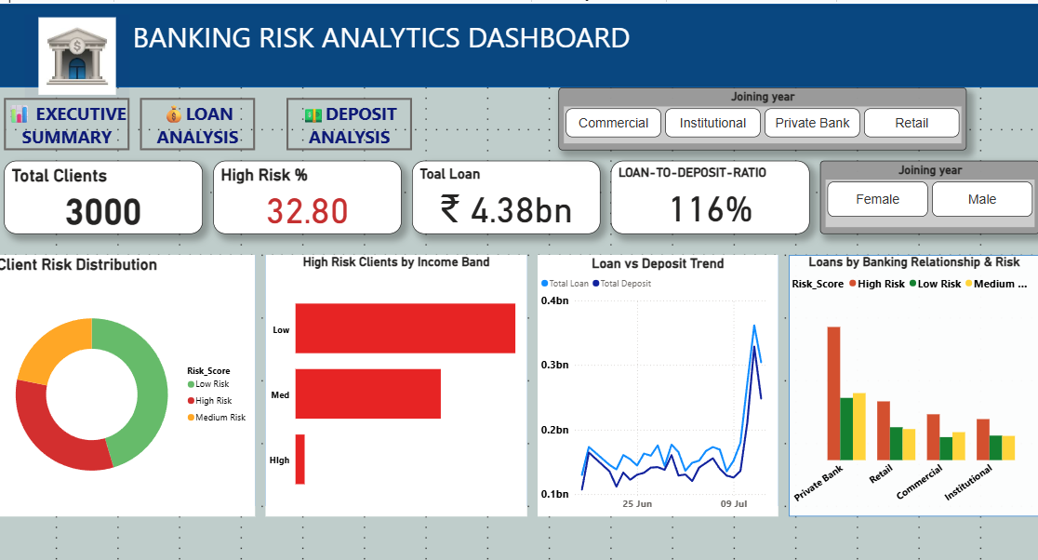

4.2 Loan Analysis
Purpose: Understand loan exposure and concentration
Insights: - Total Loan: ₹4.38bn - Business Lending dominates total exposure (₹2.6bn) - Private Banking contributes disproportionately to high-risk loan exposure
Visuals: - Bank loans by nationality - Loans by income band - Loans by engagement timeframe 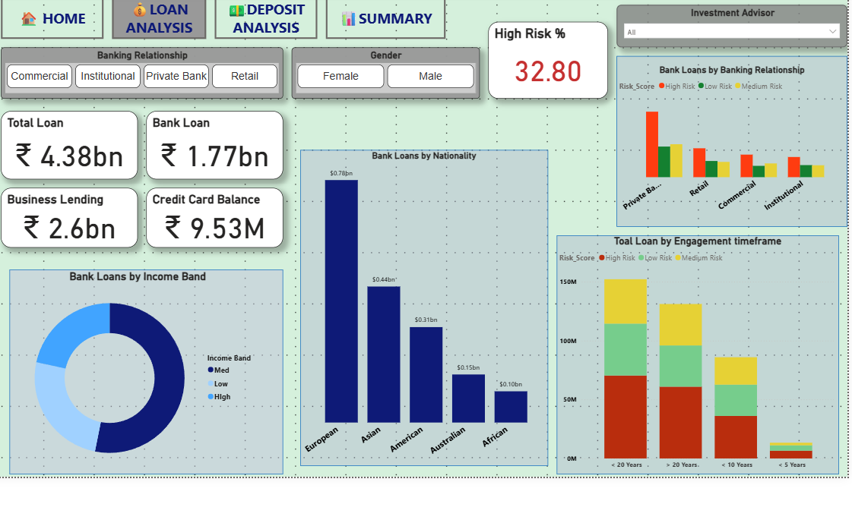

4.3 Deposit Analysis
Purpose: Evaluate funding stability and liquidity support
Insights: - Total Deposits: ₹3.77bn - Checking and Savings accounts form the bulk of deposits - European clients contribute higher deposits with lower risk
Visuals: - Deposit composition by account type - Deposits by nationality and risk - Deposits by engagement timeframe - LDR gauge with target threshold (0.80)
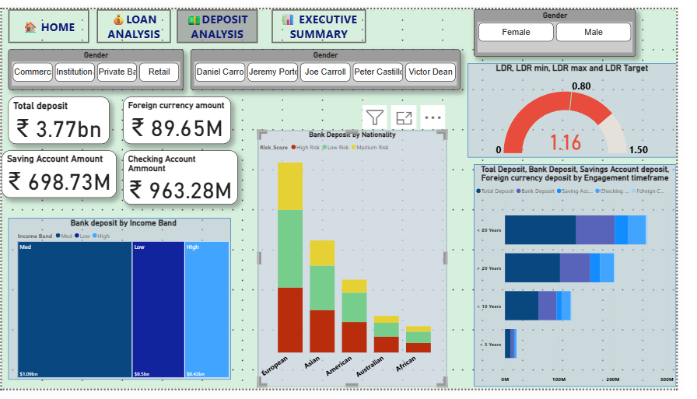

4.4 Summary & Risk Segmentation
Purpose: Combine risk, exposure, and actionability
Key Visuals: - Client Segmentation Scatter Plot (Deposits vs Loans) - Risk category table with conditional formatting - Insights & recommendations panel
Scatter Plot Interpretation: - High-risk clients cluster in high-loan / low-deposit quadrant - Low-risk clients show stronger deposit backing
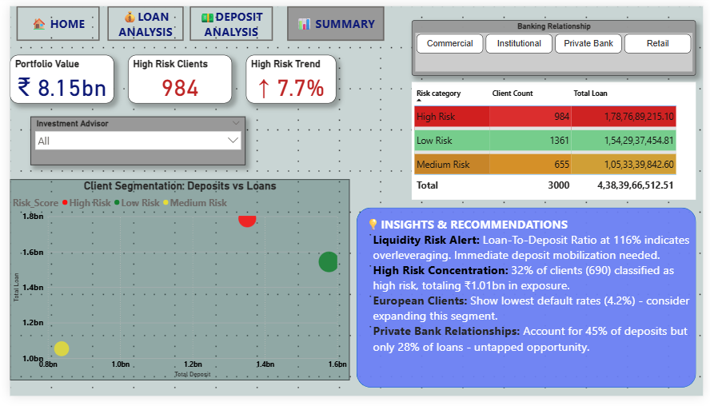

5. Key Insights

5.1 Liquidity Risk
- Loan-to-Deposit Ratio at 116% indicates overleveraging
- Loans exceed deposit base, increasing liquidity pressure

5.2 Risk Concentration
- 32.8% of clients (984) classified as High Risk
- High-risk exposure totals ₹1.78bn, representing a significant portfolio concentration

5.3 Segment-Level Insights
- Private Banking clients:
  - Contribute ~45% of deposits
  - Account for only ~28% of loans
  - Represent an opportunity for controlled loan expansion
- European clients:
  - Lowest default rates (~4.2%)
  - Strong deposit contribution

5.4 Engagement Tenure
- Clients with <10 years engagement carry higher risk-weighted loan exposure
- Longer tenure does not eliminate risk but improves deposit stability

6. Business Recommendations

6.1 Immediate Actions
- Reduce loan growth until LDR falls below 100%
- Increase deposit mobilization campaigns (fixed deposits, long-term savings)

6.2 Risk Mitigation
- Tighten credit approval for High Risk segments
- Introduce stricter collateral and pricing for high-risk clients

6.3 Growth Opportunities
- Expand lending cautiously within Private Banking segment
- Target European and Low Risk clients for portfolio growth

6.4 Monitoring & Governance
- Track High Risk % monthly
- Set early-warning triggers for LDR breaches
- Use segmentation scatter to flag risky client profiles pre-approval

7. Tools & Technologies
- Python: Pandas, NumPy, Matplotlib, Seaborn
- Power BI: DAX measures, conditional formatting, drill-through, scatter analysis
- SQL (optional): Data validation and aggregation

8. Conclusion
This Banking Risk Analytics project demonstrates how combining EDA, business KPIs, and interactive dashboards can significantly improve credit risk visibility. The solution enables banks to proactively manage exposure, reduce default probability, and balance growth with liquidity stability.
The dashboard is designed to support executive decision-making, risk management teams, and credit analysts with actionable insights rather than static reporting.

